On The Road Again –
By Joe Ingram

It was a dark and stormy night. The thunder rolled in the distance. The lightning crashed across the sky, splitting the darkness, revealing the glimpse of a castle on a far distant hill. The rain pounded the earth with such furry that neither man nor beast would venture out. Then, suddenly, the howling wind blew out the candle, a lady screamed , a gunshot - BANG …………
O K. None of that really happened. But I’ve always wanted to start a story that way. So, thanks for your tolerating my rambling.
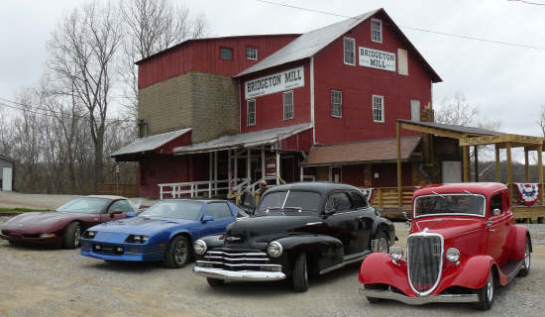
Actually, The Brandywine Cruisers of Greenfield IN, www.brandywinecruisers.com hosted their first Spring Cruise on Sat April 12th 2008. Having already traveled much of the route suggested on our own, Mike Pershing (club president) put my wife Lisa and me in charge. We had our marching orders, put it together and set out to see who could go. So, we started a contact list of others who may be interested besides the members. Then an idea - let’s e-mail even more people and find out if they are interested or know someone who is. So the e-mails and phone calls went out. The response was awesome. Within a week we had 17 positive responses. Most of them were eager and excited to get the car out of the garage and on the road after what has seemed like a very long winter. However! Most of them also qualified their enthusiasm with “weather permitting”. We also heard from friends of friends who wanted to know “can we go too?”. Of course you can The more the merrier. It looked like our first Spring Cruise would be large with just word of mouth notification.
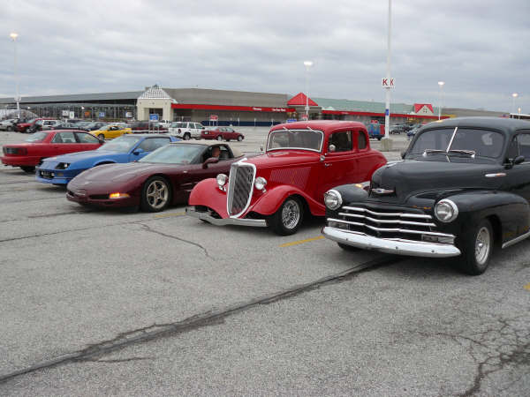
Then the list started to dwindle. Personal and family obligations arose. The weather man started talking about instead of 70 degrees and sunny it would be 40’s cold and wet. However, some calls were asking “is it still on?”. My answer was we will play it by ear. Unless on Sat morning it is heavy rain or snow, we will be going. Let’s see who shows up.

Sat. morning April 12th started out with the temperature in the 40s and scattered light rain and drizzle. At 8:00 AM in on Indy’s west side at the Meijer parking lot at Raceway and Rockville Rd. we had a gathering of four cars (couples) determined not to let the weather stop them from a fun day friendship and cruising. Joe & Lisa Ingram 1934 Ford from Indy; John & Leatrice Royer 1947 Chevy from Greenfield; Otis & Sharon Baker 2003 Corvette from Greenwood; and Jerry & Jennine Bristow 1986 IROC Camero from Bargersville. After introductions were made the first comment Jerry made was “If my car gets wet, I’ll dry it off”. I liked him immediately. The only thing I would add is if it gets dirty I’ll wash it. It was obvious that this groups version of “weather permitting” was different then that of others.
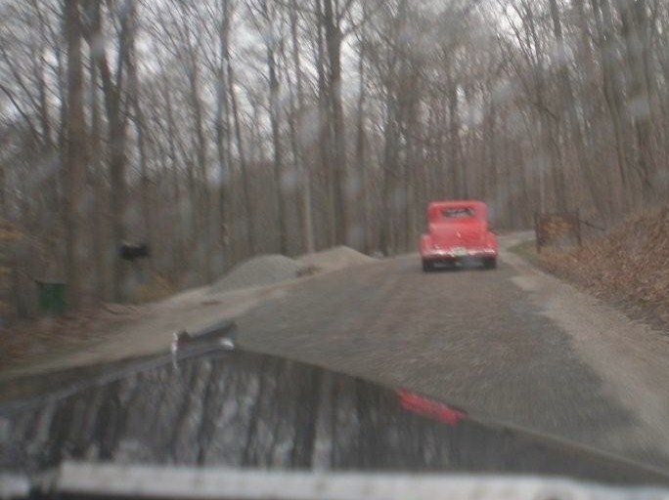
We then set out for French Lick/West Baden via Rockville. We left Indy heading west on Highway 36 to Rockville IN. where we cruised around the historic town square on streets paved with brick. Then, on to a part of the covered bridge trail called Bridgeton Rd.. Winding through the back roads of Indiana’s countryside we passed two covered bridges, being careful not to go down gravel roads. Even on a cloudy day, they are a beautiful site - silent reminders of a simpler time of days gone by.
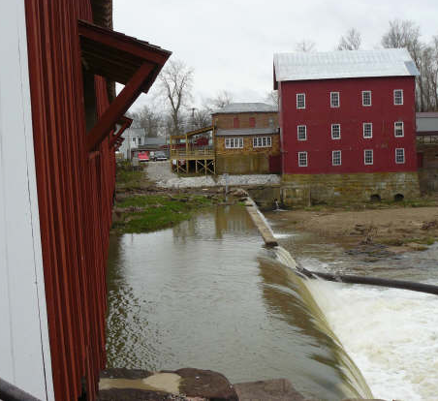
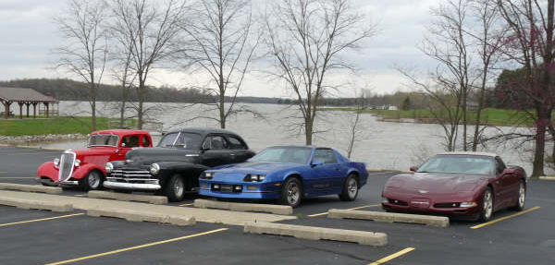
As the road makes it’s way into the town of Bridgeton, it looks as if you will cross over the covered bridge until you turn the corner and realize that you will actually drive to its left and around it to the Grist Mill. The river still runs under the covered bridge and with the high spring rushing water it makes a very cool sight. The Grist Mill was established in 1823 and is the oldest continually operated mill in Indiana according to their flyer. The covered bridge was mostly destroyed by vandals a few years ago and has been reconstructed to the original specifications from 1868 and is now only open to foot traffic. The Grist Mill was supposed to be open but was not, so we enjoyed other sites in the town and waited in the general store with hot chocolate and coffee. It was then that John and Leatrice told us that their car did not have heat. Not that the heater had quit working, but that it is not equipped with a heater. But this trip sounded so neat that they would not let that stop them from coming and enjoying it. My hat is definitely off to you both. We all waited until ten after ten and the mill was not open yet so it’s time to move on.
(Note: On Sunday April 13, the day AFTER we were at the mill and had waited past the normal opening time, Lisa received an e-mail on her phone at 3;30 in the afternoon from someone at the Grist Mill saying “What a wonderful idea to have a car club cruise to the Mill. We will open the mill early at 9:30 for you. We are looking forward to your visit on Sat. April 12th. See you then”???? You figure that one out!!!!!!)
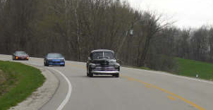
On to Hw. 59 south through Brazil, stopping at the I 70 interchange for gas and another bathroom break. Hey, I only have an 11 gal tank and John’s gas gauge does not work so better safe than sorry. Otis on the other hand has about 400 hp and gets 27 mpg. Don’t ya just hate that?
Back on the road towards Worthington & hw 231 south past Crane Naval Depot and to lunch at Stoll’s Lakeview Restaurant on the south end of West Boggs Park. This is an authentic Amish style Buffet that is worth stopping at if you are anywhere close to it. We all talked and laughed and ate too much. Even Jennine ate dessert, though she said that she was only going to look.
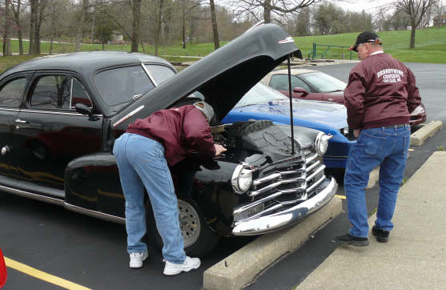
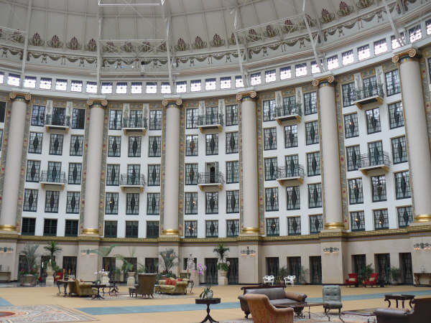
At lunch John said that his 47 had developed a miss. So afterwards we popped the hood for a look. Nothing obvious so he started it up. Whoa - found a fuel leak! So, after Jerry & Jennine made a parts run into Loogootee for a hose and some clamps, we are on our way again. Thanks you two.
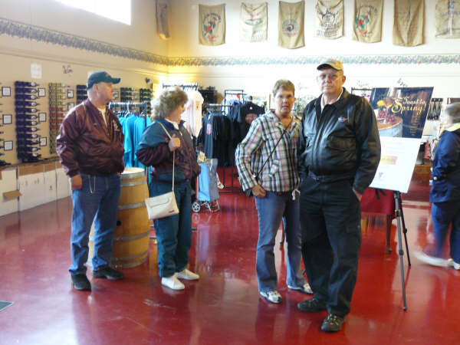
Through the town of Loogootee and onto 56 west into French Lick and West Baden where we stopped at the French Lick Winery for a little wine tasting. This is just one of the eight in a group of wineries that is called the Upland trail. You can cruise to all of them for a unique experience. For more info go to www.indianaupland.com . Or, they are part of a larger group of wineries that provide wine tasting, food, and live entertainment for your enjoyment. For more info go to www.indianawines.org.
Now down the block and across the street to the West Baden Hotel. A must see if you are anywhere close to this area. The drive down the brick covered street past the grand entrance is absolutely beautiful, even with the acres of plush grass still covered with standing water. And once inside you are treated to a stunning recreation of the grandeur of the turn of the century when it was visited by Presidents and gangsters alike. (The massive atrium is akin to the spectacular structure that we saw at The Biltmore Estate in Ashville NC.) Do not miss experiencing this landmark. It alone was worth the trip.
But the day is waning and it is a two hour trip back up Hw 37. So north we headed to our final stop, dinner at Gray Brothers Cafeteria in Moorsville. The total mileage of the cruise was about 300 miles and a tired but happy group once again laughed and ate too much and spoke of the great time we had shared today.
We all agreed that the time spent together today was a wonderful experience. It was a day about enjoying our cars, the scenery, the food and each other’s friendship. It was about making memories no matter what the weather would bring - memories that will last a life time.
No, it wasn’t 70 degrees and sunny. It was 40s and drizzle. But it turned out to be a great day spent with a great group of friends.
I’ll wash the car tomorrow !!

Joe Ingram
Brandywine Cruiser

